10/20/2023

INFORMATION AND COMMUNICATION TECHNOLOGY

# ASSIGNMENT: 01

## SUBMITTED TO: MISS WASEEQA GHAZANFAR

## SUBMITTED BY: BAREERA HAMEED

## REG NO: 231598

## BS-CS (1-C)

# **The Interaction Between Asthma, Emotions, and Expectations in the Time of COVID-19**

**Authors** [Volpato E](https://www.dovepress.com/author_profile.php?id=879717) , [Banfi P](https://www.dovepress.com/author_profile.php?id=454576) , [Pagnini F](https://www.dovepress.com/author_profile.php?id=461857)

INTRODUCTION:

Since the beginning of its spread, the COVID-19 pandemic, which emerged at the end of 2019, has been considered particularly threatening to people in fragile conditions, such as the elderly, with multiple diseases, especially respiratory diseases, who already have higher levels of stress, anxiety, and depression.

There were more than 262 million people in 2019 worldwide who suffered from asthma, and it has been hypothesized that it caused 461,000 deaths.[[1]](#cit0001)The symptoms and their worsening are associated with the limitation of functional and physical activities in work, relational and social problems, as well as a significant reduction in Quality of Life (QoL). Compared to the general population, also before the pandemic, there was a six-fold increase in anxiety,2,3 panic disorder,4 and depression.5,6 In addition, it has been shown that people with severe asthma, which is more difficult to manage and control, are often characterized by a greater number of comorbidities and poly-pharmacology or poly-treatment, which in turn decrease levels of adherence, QoL and contribute to the use of maladaptive coping strategies.5 Therefore, the subjective well-being of people with asthma is considerably tested by the experience of their symptoms and treatments,7 resulting in a vicious circle, in elevated healthcare costs and potential health complications.8 This situation worsened considerably during the pandemic period, causing many people with asthma to even avoid check-ups or access to treatment services for fear of contracting the virus,9,10 and resulting in relevant control pipelines and frantic cleaning.11 Lackwik et al12 found that high levels of state and trait anxiety play a significant role as potential factors for loss of control in the management of asthma-related symptoms, resulting in a consequent decline in Health-Related Quality of Life (HRQoL). However, most studies have focused on anxiety, depression, and QoL10,13,14 to describe and improve healthcare services that promote well-being among people with asthma during the pandemic period, providing few indicators about the beliefs, expectations, and emotional experiences of people with asthma about the pandemic moment.



## Methods

### **Ethics:**

The project was conducted following the Declaration of Helsinki, and the protocol was approved by the Ethics Committee of the Università Cattolica del Sacro Cuore (cod. 35–18, 21/12/2018), in Milan (Italy). The consent form was shared before undertaking the interview according to Italian Law 196/2003 on Privacy and Safeguarding of Sensitive Data and the GDPR of the European Union 2016/679. The participants informed consent included publication of anonymized responses.

### **Patient and Public Involvement:**

Patients were involved in the recruitment, reporting, and dissemination plans of this research. Results and publication of the research will be disseminated to all study participants via email. Refer to the subparagraphs of the Methods section for further details.

### **Study Design:**

This was a qualitative study using Interpretative Phenomenological Analysis (IPA),15 conducted and reported following the Consolidated Criteria for Reporting Qualitative Research (COREQ).16

### **Inclusion and Exclusion Criteria:**

Participants were included in case of a confirmed diagnosis of at least 6-months of mild or moderate persistent asthma according to the Global Initiative for Asthma (GINA)17by the pulmonologist; adults; they spoke Italian; non-pregnant; without serious comorbidities (eg, cancer, immunosuppressive conditions) or an impaired mental condition based on available medical records.

### **Recruitment:**

Consistent with IPA’s idiographic approach,15 sampling focused on recruiting a specific and heterogeneous group, according to the listed criteria.17 To reduce the potential for biases, a random sampling procedure was adopted using the system promoted by random.org. A consecutive series of 118 adult people with a confirmed diagnosis by the Pulmonologist were randomly selected from the outpatient accesses of the XXX of the XXX, in XX (XX) and were invited to take part in the study by email. Sampling is concluded upon reaching data saturation.

### **Data Collection:**

Participants were recruited during the period between the first and the second wave of COVID-19, between 15th March and 30th June 2020. Due to the health emergency, the meeting took place either by phone or through a platform enabling video calls. All interviews were conducted by a registered psychologist (EV) who was specially trained in both the handling of the clinical relationship and the use of the IPA. They were all audio-recorded and lasted approximately 30 minutes.

The interviews were semi-structured, exploring the experiences of living with asthma at the time of COVID-19 and paying attention to the relationship between asthma symptoms, emotions, cognitions, beliefs, and expectations. According to IPA, the interviewer was free to probe interesting areas that arose as well as she could follow the respondent’s interests or concerns, monitoring the effects of the answers on the respondent.15 Field notes, which supplemented analysis, were taken after conducting each interview. The structure of the interview is shown in Table 1.

# **Table: 1**

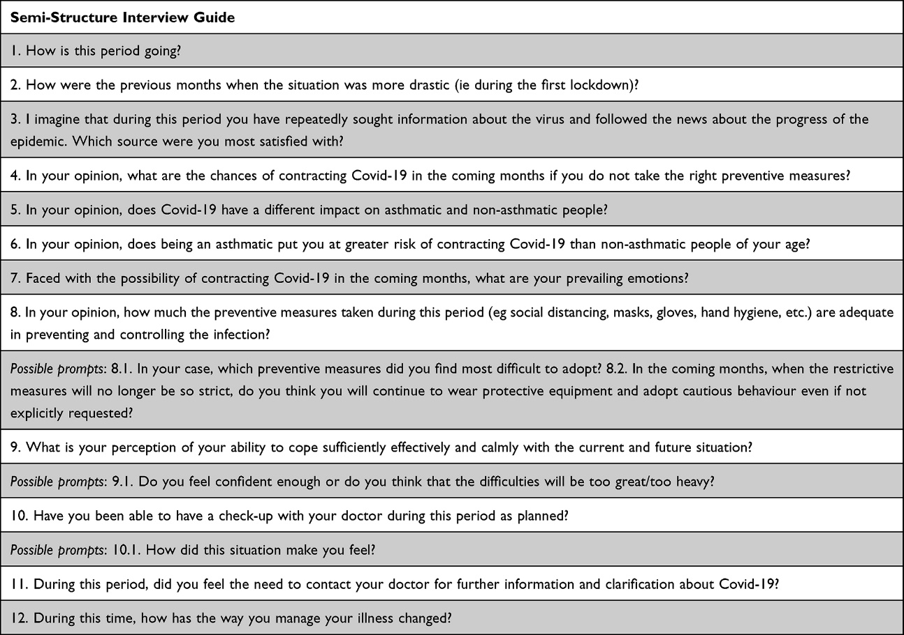

**Table 1** Semi-Structure Interview Schedule

### **Data Analysis:**

IPA allows access to the respondent’s inner world, in the form of both beliefs and parts of identity that are made manifest or suggested by the respondent’s speech. The meaning that the respondent ascribes is central and unique and the aim is to try to understand the content and complexity of this rather than to measure its frequency.18

The researchers gave space throughout the analysis process to reflexivity, encouraging them to understand how their point of view could impact the research itself, preventing personal experiences and one’s prejudices from influencing the results.19

Using NVivo software (QSR International®, version 12) and following the IPA approach,15 the analysis was developed through six different phases: Reading and re-reading; Coding; Clustering; Iteration; Narration; Contextualisation.

Once heard and transcribed verbatim, the researchers (EV; FP) initially coded them separately to ensure internal consistency. The themes that emerged were then discussed until the final themes were outlined. A third researcher (PB) intervened to resolve any doubts and reconciled differences.



## Results:

### **Participant Demographics:**

Thirty-one candidates participated in the study. Three people replied to the email denying their availability for personal reasons at the time (eg, illness). The others did not reply. Among those who did not respond to the invitation, we know that the mean age is 57.2 (SD=15) and there are 54 women and 30 men.

Table 2shows the main socio-demographic characteristics of those who took part in the study.

# **Table: 2**

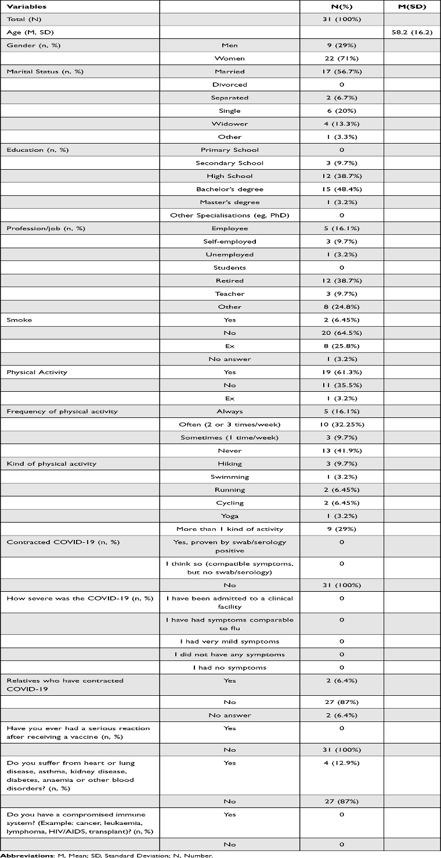

Overall, the words most frequently used by the participants were, in order: “period” (260 references; 0.59% coverage); “covid” (219 references; 0.50% coverage); “measures” (132 references; 0.30% coverage); “people” (132 references; 0.30% coverage); “mask” (123 references; 0.28% coverage).

### **Superordinated Themes:**

The super ordered themes were “illness”, “experienced emotions”, “beliefs”, “expectations”, and “behaviours”. Each superordinate theme is characterised by the presence of specific themes and sub-themes. Table 3reports the structure of superordinate themes, themes, and sub-themes, as well as the frequencies with which the different themes emerged.

# Table: 3

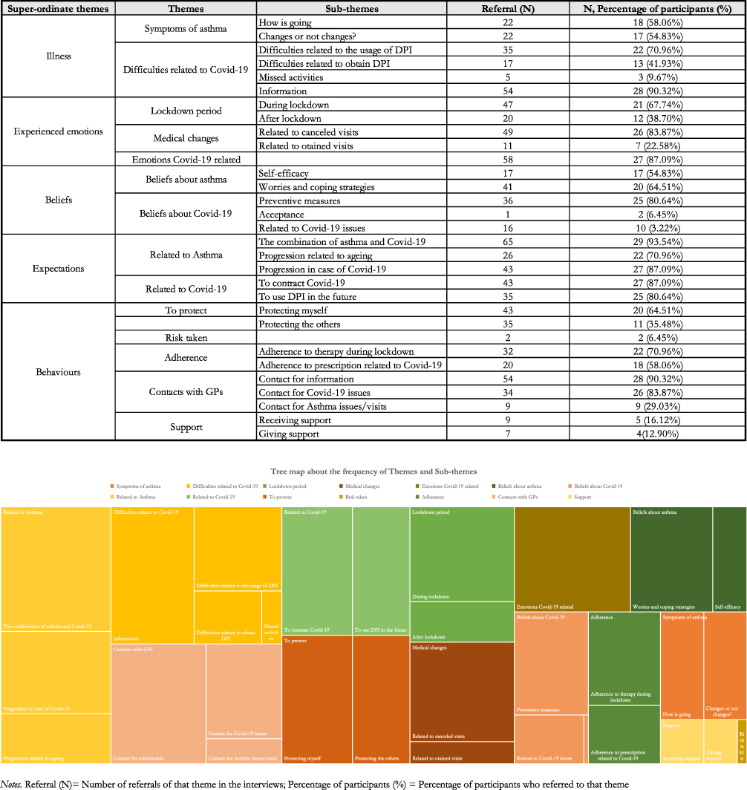

**Table 3** The referral and percentage of superordinate themes, themes and sub-themes in this dataset.

The superordinate theme of “illness” refers to how one’s illness is perceived in terms of signs and symptoms and whether changes have been noticed. “Experienced emotions”, instead, allows denoting the inner experiences of people with asthma during and following the period of the first lockdown, as well as those related to cancellations or the possibility of obtaining a medical examination. The superordinate themes of “beliefs” and “expectations” are configured around the progressions and characteristics of asthma and COVID-19. Finally, the superordinate theme of “behaviour” reveals the actions taken towards oneself and others to protect oneself from the virus, and in adhering to asthma treatment prescriptions  shows the distribution of themes and sub-themes in relation to the type of asthma.

# Differential Equations of Biology

1.

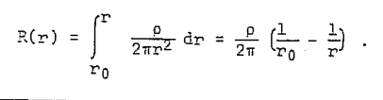

## Key Messages:

The impact of COVID-19 on people with asthma appears complex, being moderated by multiple illness-specific, demographic, and environmental interacting factors. Given that other coronaviruses cause asthma exacerbations, concerns have been raised about the impact of COVID-19 in people with asthma. However, little was known about the specific experiences, emotions, beliefs, and expectations of individuals with mild-to-moderate persistent asthma during the COVID-19 pandemic. This study adds new insights into the emotional and cognitive impact of COVID-19 on people with asthma, including the challenges they faced in managing their asthma and the emotional burden of living with a chronic respiratory condition during a pandemic. The study also highlights the importance of continuity of care and self-efficacy in managing chronic illnesses during times of uncertainty.

The findings of this study may inform future research on the psychological and emotional impact of COVID-19 on individuals with chronic illnesses, particularly those with respiratory conditions. The study also has practical implications for healthcare providers, highlighting the importance of providing ongoing support and education to patients with asthma to help them manage their condition during the pandemic. The study may also inform policy decisions related to healthcare provision and support for individuals with chronic illnesses during times of crisis. Overall, the study underscores the importance of taking a patient-centered approach to health care, particularly for individuals with chronic illnesses, during times of uncertainty and crisis.

## Abbreviations:

COVID-19 or SARS-Cov-2, Coronavirus disease 19; QoL, Quality of Life; HRQoL, Health-Related Quality of Life; IPA, Interpretative Phenomenological Analysis; COREQ Consolidated Criteria for Reporting Qualitative Research; GINA, Global Initiative for Asthma.

## Conclusions:

This study showed different psychosocial aspects of living with a chronic respiratory condition during a pandemic period, demonstrating the complex interplay between emotions, beliefs, expectations, and behaviour that changed just in a limited period as the first wave. The healthcare systems of all countries should consider constantly training their staff so that they can promptly offer remote support at multiple levels (health, psychological, social) and that the patient is aware of it.

## References

[1.](https://www.dovepress.com/the-interaction-between-asthma-emotions-and-expectations-in-the-time-o-peer-reviewed-fulltext-article-JAA" \l "ref-cit0001) World Health Organization W.Chronic Respiratory Disease-Asthma; 2018. Available from: <http://www.who.int/respiratory/asthma/en>. Accessed October 16, 2023.

[2.](https://www.dovepress.com/the-interaction-between-asthma-emotions-and-expectations-in-the-time-o-peer-reviewed-fulltext-article-JAA" \l "ref-cit0002) Ye G, Baldwin DS, Hou R. Anxiety in asthma: a systematic review and meta-analysis. Psychol Med. 2021;51(1):11–20. doi:10.1017/S0033291720005097

[3.](https://www.dovepress.com/the-interaction-between-asthma-emotions-and-expectations-in-the-time-o-peer-reviewed-fulltext-article-JAA" \l "ref-cit0003) Thomas M, Bruton A, Moffatt M, Cleland J. Asthma and psychological dysfunction. Primary Care Respiratory J. 2011;20(3):250–256. doi:10.4104/pcrj.2011.00058

[4.](https://www.dovepress.com/the-interaction-between-asthma-emotions-and-expectations-in-the-time-o-peer-reviewed-fulltext-article-JAA" \l "ref-cit0004) Del Giacco SR, Cappai A, Gambula L, et al. The asthma-anxiety connection. Respir Med. 2016;120:44–53. doi:10.1016/j.rmed.2016.09.014

[5.](https://www.dovepress.com/the-interaction-between-asthma-emotions-and-expectations-in-the-time-o-peer-reviewed-fulltext-article-JAA" \l "ref-cit0005) Stanescu S, Kirby SE, Thomas M, Yardley L, Ainsworth B. A systematic review of psychological, physical health factors, and quality of life in adult asthma. NPJ Prim Care Respir Med. 2019;29(1):37. doi:10.1038/s41533-019-0149-3

[6.](https://www.dovepress.com/the-interaction-between-asthma-emotions-and-expectations-in-the-time-o-peer-reviewed-fulltext-article-JAA" \l "ref-cit0006) Anastasia P, Eleni T, Eleftheria M, et al. Depression Levels Influence the Rate of Asthma Exacerbations in Females. J Pers Med. 2021;11(6):586. doi:10.3390/jpm11060586

[7.](https://www.dovepress.com/the-interaction-between-asthma-emotions-and-expectations-in-the-time-o-peer-reviewed-fulltext-article-JAA" \l "ref-cit0007) Hughes M, Dunne M. The living with asthma study: issues affecting the perceived health and well-being of Irish adults with asthma. Ir J Med Sci. 2016;185(1):115–120. doi:10.1007/s11845-014-1232-y

[8.](https://www.dovepress.com/the-interaction-between-asthma-emotions-and-expectations-in-the-time-o-peer-reviewed-fulltext-article-JAA" \l "ref-cit0008) Riley IL, Jackson B, Crabtree D, et al. A Scoping Review of International Barriers to Asthma Medication Adherence Mapped to the Theoretical Domains Framework. J Allergy Clin Immunol Pract. 2021;9(1):410–418.e4. doi:10.1016/j.jaip.2020.08.021

[9.](https://www.dovepress.com/the-interaction-between-asthma-emotions-and-expectations-in-the-time-o-peer-reviewed-fulltext-article-JAA" \l "ref-cit0009) de Boer GM, Houweling L, Hendriks RW, Vercoulen JH, Tramper-Stranders GA, Braunstahl GJ. Asthma patients experience increased symptoms of anxiety, depression and fear during the COVID-19 pandemic. Chron Respir Dis. 2021;18:1–7. doi:10.1177/14799731211029658/SUPPL_FILE/SJ-PDF-1-CRD-10.1177_14799731211029658.PDF

[10.](https://www.dovepress.com/the-interaction-between-asthma-emotions-and-expectations-in-the-time-o-peer-reviewed-fulltext-article-JAA" \l "ref-cit0010) Higbee DH, Nava GW, Kwong ASF, Dodd JW, Granell R. The impact of asthma on mental health and wellbeing during COVID-19 lockdown. Eur Respir J. 2021;58(1):2004497. doi:10.1183/13993003.04497-2020

[11.](https://www.dovepress.com/the-interaction-between-asthma-emotions-and-expectations-in-the-time-o-peer-reviewed-fulltext-article-JAA" \l "ref-cit0011) Sheha DS, Abdel-Rehim AS, Abdel-Latif OM, et al. Level of asthma control and mental health of asthma patients during lockdown for COVID-19: a cross-sectional survey. Egyptian J Bronchol. 2021;15(1):12. doi:10.1186/s43168-021-00058-x

[12.](https://www.dovepress.com/the-interaction-between-asthma-emotions-and-expectations-in-the-time-o-peer-reviewed-fulltext-article-JAA" \l "ref-cit0012) Lacwik P, Szydłowska D, Kupczyk M, Pałczyński C, Kuna P. High levels of anxiety during the COVID-19 pandemic as a risk factor of clinical worsening in patients with severe asthma. J Allergy Clin Immunol Pract. 2021;9(3):1381–1383. doi:10.1016/j.jaip.2020.12.060

[13.](https://www.dovepress.com/the-interaction-between-asthma-emotions-and-expectations-in-the-time-o-peer-reviewed-fulltext-article-JAA" \l "ref-cit0013) Daşdemir KA, Suner-Keklik S. Physical activity, sleep, and quality of life of patients with asthma during the COVID-19 pandemic. J Asthma. 2021;1–7. doi:10.1080/02770903.2021.1931303

[14.](https://www.dovepress.com/the-interaction-between-asthma-emotions-and-expectations-in-the-time-o-peer-reviewed-fulltext-article-JAA" \l "ref-cit0014) Kwong ASF, Pearson RM, Adams MJ, et al. Mental health before and during the COVID-19 pandemic in two longitudinal UK population cohorts. Br J Psychiatry. 2021;218(6):334–343. doi:10.1192/bjp.2020.242

[15.](https://www.dovepress.com/the-interaction-between-asthma-emotions-and-expectations-in-the-time-o-peer-reviewed-fulltext-article-JAA" \l "ref-cit0015) Spiers J, Smith JA. Interpretative Phenomenological Analysis. Atkinson P, Delamont S, ed.; 2019. doi:10.4135/9781526421036813346

[16.](https://www.dovepress.com/the-interaction-between-asthma-emotions-and-expectations-in-the-time-o-peer-reviewed-fulltext-article-JAA" \l "ref-cit0016) Tong A, Sainsbury P, Craig J. Consolidated criteria for reporting qualitative research (COREQ): a 32-item checklist for interviews and focus groups. Int J Quality Health Care. 2007;19(6):349–357. doi:10.1093/intqhc/mzm042

[17.](https://www.dovepress.com/the-interaction-between-asthma-emotions-and-expectations-in-the-time-o-peer-reviewed-fulltext-article-JAA" \l "ref-cit0017) Reddel HK, Bacharier LB, Bateman ED, et al. Global Initiative for Asthma Strategy 2021: executive Summary and Rationale for Key Changes. Am J Respir Crit Care Med. 2022;205(1):17–35. doi:10.1164/rccm.202109-2205PP

[18.](https://www.dovepress.com/the-interaction-between-asthma-emotions-and-expectations-in-the-time-o-peer-reviewed-fulltext-article-JAA" \l "ref-cit0018) Smith JA, Osborn M. Interpretative Phenomenological Analysis. In: Smith JA, editor. Qualitative Psychology: A Practical Guide to Methods. SAGE Publications; 2003:53–80.

[19.](https://www.dovepress.com/the-interaction-between-asthma-emotions-and-expectations-in-the-time-o-peer-reviewed-fulltext-article-JAA" \l "ref-cit0019) Engward H, Goldspink S. Lodgers in the house: living with the data in interpretive phenomenological analysis research. Reflective Practice. 2020;21(1):41–53. doi:10.1080/14623943.2019.1708305

[20.](https://www.dovepress.com/the-interaction-between-asthma-emotions-and-expectations-in-the-time-o-peer-reviewed-fulltext-article-JAA" \l "ref-cit0020) Philip KEJ, Lonergan B, Cumella A, Farrington-Douglas J, Laffan M, Hopkinson NS. COVID-19 related concerns of people with long-term respiratory conditions: a qualitative study. BMC Pulm Med. 2020;20(1):319. doi:10.1186/s12890-020-01363-9

[21.](https://www.dovepress.com/the-interaction-between-asthma-emotions-and-expectations-in-the-time-o-peer-reviewed-fulltext-article-JAA" \l "ref-cit0021) Mazza C, Ricci E, Biondi S, et al. A Nationwide Survey of Psychological Distress among Italian People during the COVID-19 Pandemic: immediate Psychological Responses and Associated Factors. Int J Environ Res Public Health. 2020;17(9):3165. doi:10.3390/ijerph17093165

[22.](https://www.dovepress.com/the-interaction-between-asthma-emotions-and-expectations-in-the-time-o-peer-reviewed-fulltext-article-JAA" \l "ref-cit0022) Ozamiz-Etxebarria N, Dosil-Santamaria M, Picaza-Gorrochategui M, Idoiaga-Mondragon N. Niveles de estrés, ansiedad y depresión en la primera fase del brote del COVID-19 en una muestra recogida en el norte de España. Cad Saude Publica. 2020;36(4). doi:10.1590/0102-311x00054020

[23.](https://www.dovepress.com/the-interaction-between-asthma-emotions-and-expectations-in-the-time-o-peer-reviewed-fulltext-article-JAA" \l "ref-cit0023) Fisher A, Roberts A, McKinlay AR, Fancourt D, Burton A. The impact of the COVID-19 pandemic on mental health and well-being of people living with a long-term physical health condition: a qualitative study. BMC Public Health. 2021;21(1):1801. doi:10.1186/s12889-021-11751-3

[24.](https://www.dovepress.com/the-interaction-between-asthma-emotions-and-expectations-in-the-time-o-peer-reviewed-fulltext-article-JAA" \l "ref-cit0024) Razu SR, Nishu NA, MdF R, Talukder A, Knowledge WPR. Attitudes, and Practices Concerning COVID-19 in Bangladesh: a Qualitative Study of Patients With Chronic Illnesses. Front Public Health. 2021;9. doi:10.3389/fpubh.2021.628623

[25.](https://www.dovepress.com/the-interaction-between-asthma-emotions-and-expectations-in-the-time-o-peer-reviewed-fulltext-article-JAA" \l "ref-cit0025) V CY, Gillies CL, Zaccardi F, et al. Impact of COVID-19 on routine care for chronic diseases: a global survey of views from healthcare professionals. Diabetes Metab Syndr. 2020;14(5):965–967. doi:10.1016/j.dsx.2020.06.042

[26.](https://www.dovepress.com/the-interaction-between-asthma-emotions-and-expectations-in-the-time-o-peer-reviewed-fulltext-article-JAA" \l "ref-cit0026) Akalu Y, Ayelign B, Knowledge MMD. Attitude and Practice Towards COVID-19 Among Chronic Disease Patients at Addis Zemen Hospital, Northwest Ethiopia. Infect Drug Resist. 2020;13:1949–1960. doi:10.2147/IDR.S258736

[27.](https://www.dovepress.com/the-interaction-between-asthma-emotions-and-expectations-in-the-time-o-peer-reviewed-fulltext-article-JAA" \l "ref-cit0027) Zhong BL, Luo W, Li HM, et al. Knowledge, attitudes, and practices towards COVID-19 among Chinese residents during the rapid rise period of the COVID-19 outbreak: a quick online cross-sectional survey. Int J Biol Sci. 2020;16(10):1745–1752. doi:10.7150/ijbs.45221

[28.](https://www.dovepress.com/the-interaction-between-asthma-emotions-and-expectations-in-the-time-o-peer-reviewed-fulltext-article-JAA" \l "ref-cit0028) Tagliabue F, Galassi L, Mariani P. The “Pandemic” of Disinformation in COVID-19. SN Compr Clin Med. 2020;2(9):1287–1289. doi:10.1007/S42399-020-00439-1

[29.](https://www.dovepress.com/the-interaction-between-asthma-emotions-and-expectations-in-the-time-o-peer-reviewed-fulltext-article-JAA" \l "ref-cit0029) Olmastroni E, Galimberti F, Tragni E, Catapano AL, Casula M. Impact of COVID-19 Pandemic on Adherence to Chronic Therapies: a Systematic Review. International Journal of Environmental Research and Public Health. 2023;20(5):3825. doi:10.3390/ijerph20053825

[30.](https://www.dovepress.com/the-interaction-between-asthma-emotions-and-expectations-in-the-time-o-peer-reviewed-fulltext-article-JAA" \l "ref-cit0030) Holland AE, Malaguti C, Hoffman M, et al. Home-based or remote exercise testing in chronic respiratory disease, during the COVID-19 pandemic and beyond: a rapid review. Chron Respir Dis. 2020;17:147997312095241. doi:10.1177/1479973120952418

[31.](https://www.dovepress.com/the-interaction-between-asthma-emotions-and-expectations-in-the-time-o-peer-reviewed-fulltext-article-JAA" \l "ref-cit0031) Greiwe J, Nyenhuis SM. Wearable Technology and How This Can Be Implemented into Clinical Practice. Curr Allergy Asthma Rep. 2020;20(8):36. doi:10.1007/s11882-020-00927-3

1.